P&Z
Montgomery County Planning and Zoning
310 Salisbury St., Ste. D
Montgomery City, Mo 63361
573-564-2142
planningzoning@mcmo.us

March 4, 2025

P&Z Commissioner

Dear Commissioner:

Happy National Pound Cake Day! A quick reminder letter, there will be a public hearing for Christy Minerals LLC on the John Imo property for fire clay mining on Tuesday, March 18, 2025. This is a rescheduled hearing, please verify you can make it, I would hate to have the hearing postponed again for another County excuse/reason. The packet you received last month is basically the same exhibits as will be presented in the hearing, only difference will be added rescheduled dated material. Bring the packet with you, please.
Below is the agenda for the monthly meeting. The next hearing/meeting will be held in the Commissioner’s room of the Courthouse on March 18, 2025 starting at 7:00p.m.- sorry, no food for this month. If you have any questions or comments, please let me know and don’t forget to celebrate National Pound Cake Day with a piece (or two) of this deliciously rich delight!
Sincerely,
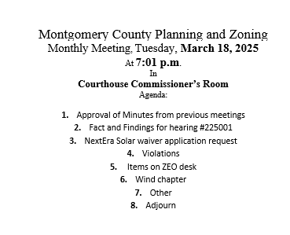
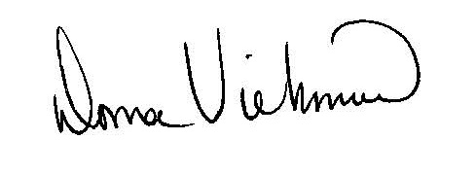
Donna Viehmann
Zoning Administrator

cc: file

