P&Z
Montgomery County Planning and Zoning
310 Salisbury St., Ste. D
Montgomery City, Mo 63361
573-564-2142
planningzoning@mcmo.us

December 26, 2024

P&Z Commissioner

Dear Commissioner:

Good day Commissioner! Just a quick letter to remind you there will be a public hearing for relocation of existing cabinetry manufacturing and wood components project on Tuesday, January 21, 2025. Enclosed you will find the packet of exhibits. Please bring said packet to the meeting, as I will not have copies on hand.
Enclosed you will also find the minutes to the November 19, 2024 monthly meeting and the public hearing minutes for Hershel Callahan rezone hearing and Callahan Family rezone hearing dated November 19, 2024. There is also a new Support Decision on Conditional Use worksheet for you to review. This is now a new supplement to the old Fact and Findings form we fill out. Below is the agenda for the monthly meeting. The next hearing/meeting will be held in the Commissioner’s room of the Courthouse on January 21, 2025 starting at 7:00p.m.- sorry, no food for this month. If you have any questions or comments, please let me know.

Sincerely,
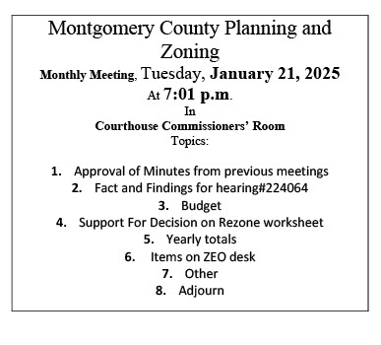
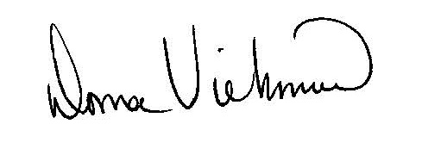
Donna Viehmann
Zoning Administrator

cc: file

enclosures

