P&Z
Montgomery County Planning and Zoning
310 Salisbury St., Ste. D
Montgomery City, Mo 63361
573-564-2142
planningzoning@mcmo.us

November 8, 2024

Planning and Zoning Commission:

Dear Member,

Hello all!
It’s that time again, the dreaded time change, come to work in the dark and go home in the dark! On November 19, 2024 we will meet again for two public hearings, beginning at 7:00pm in the Commissioners’ room of the Courthouse. The paperwork for both hearings is enclosed, please remember to bring it with you that evening. Also enclosed you will find the minutes from the October meeting. Below is the agenda for the monthly meeting following the public hearings.

Sincerely,
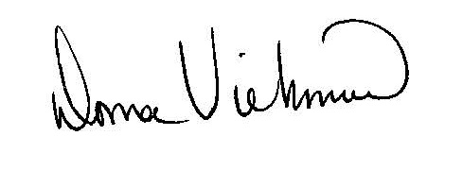
Donna Viehmann
Zoning Administrator

cc: file
enclosures

Montgomery County Planning and Zoning
Monthly Meeting, Tuesday, November 19, 2024
At 7:00 p.m.
In
Commissioners’ Room of Courthouse
Agenda:

- Call to Order
- Approval of Minutes from previous meetings
- 2025 hearing/deadline dates
- Board member appointments
- Items on ZEO desk
- Monthly totals
- Other
- Adjourn

