P&Z
Montgomery County Planning and Zoning
310 Salisbury St., Ste. D
Montgomery City, Mo 63361
573-564-2142
planningzoning@mcmo.us

January 29, 2025

P&Z Commissioner

Dear Commissioner:

Happy Curmudgeons Day, Commissioner! Just a quick letter, from your favorite ill-tempered, disagreeable Zoning Administrator, to remind you there will be a public hearing for Christy Minerals LLC on the John Imo property for fire clay mining on Tuesday, February 18, 2025. Enclosed you will find the packet of exhibits, along with the new ‘support decision on conditional use worksheet’. Please bring said packet to the meeting, as I will not have copies on hand.
Enclosed you will also find the minutes for the January 21,2025 monthly meeting and the public hearing minutes for Hartman Cabinetry relocation conditional use hearing dated January 21, 2025. Below is the agenda for the monthly meeting. The next hearing/meeting will be held in the Commissioner’s room of the Courthouse on February 18, 2025 starting at 7:00p.m.- sorry, no food for this month. If you have any questions or comments, please let me know and I will try very hard to be less curmudgeon like 😊

Sincerely,
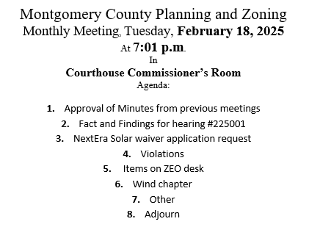
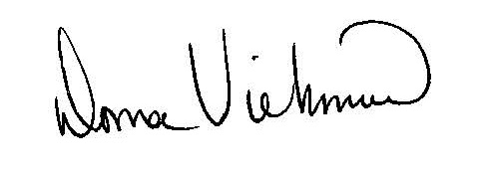
Donna Viehmann
Zoning Administrator

cc: file

enclosures

