P&Z
Montgomery County Planning and Zoning
310 Salisbury St., Ste. D
Montgomery City, Mo 63361
573-564-2142
planningzoning@mcmo.us

September 9, 2024

Planning and Zoning Commission:

Dear Member,

Hello all!
I’ll make this short and sweet. Public Hearing for adding a Data Center to the Land/Building Use Grid Chart and Data Center definition will be presented for discussion/vote on September 17, 2024. The minutes from the June meeting are enclosed.
The next public hearing is on September 17, 2024 in the County Commission Room starting at 7:00p.m. Please let me know if you have any questions.

Sincerely,
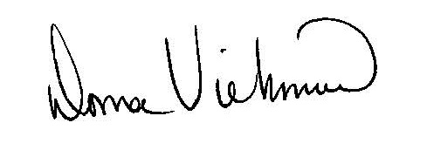
Donna Viehmann
Zoning Administrator

cc: file

Montgomery County Planning and Zoning
Monthly Meeting, Tuesday, September 17, 2024
At 7:00 p.m.
In
Commissioner’s Room
Topics:

- Fact and Findings for Data Center Land/Building Use Grid Chart and Definition
- Approval of Minutes from previous meetings
- Items on ZEO desk
- Other
- Adjourn

