P&Z
Montgomery County Planning and Zoning
310 Salisbury St., Ste. D
Montgomery City, Mo 63361
573-564-2142
planningzoning@mcmo.us

May 10, 2024

Planning and Zoning Commission:

Dear Member,

Happy National Shrimp Day! Our next meeting date is May 21, 2024 at 7:00pm in the Courthouse Annex (Planning and Zoning Office). Below is the agenda for the evening. Earlier in the week the office had a call from Brandon Woodall, he would like to come visit the P&Z Commission sometime about the Solar Ordnance; the cool season grass recommendation and the screening used. If he comes to this meeting, he will be the first item of business.
The next public meeting is on May 21, 2024 in the Courthouse Annex (Planning and Zoning Office) starting at 7:00p.m. Please let me know if you plan to attend or not. There will be sandwiches, so no shrimp po’boys. See you soon.

Sincerely,
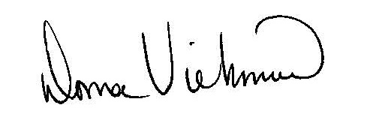
Donna Viehmann
Zoning Administrator

cc: file

Montgomery County Planning and Zoning
Monthly Meeting, Tuesday, May 21, 2024
At 7:00 p.m.
In
County Commissioners Room
Topics:

- Call to Order
- Brendan Woodall-Solar
- Approval of Minutes from previous meetings
- Wind Chapter
5. Items on ZEO desk
6. Monthly totals
7. Other
8. Adjourn

